**Introduction to jQuery**

1. **Console "Hello Word" in document.ready function**

**Ans-** <html>

<head>

<title>The jQuery Example</title>

<script type = "text/javascript"

src = "https://ajax.googleapis.com/ajax/libs/jquery/2.1.3/jquery.min.js">

</script>

<script type = "text/javascript">

$(document).ready(function() {

console.log("Hello World");

});

</script>

</head>

<body>

<h1>First 1</h1>

</body>

</html>

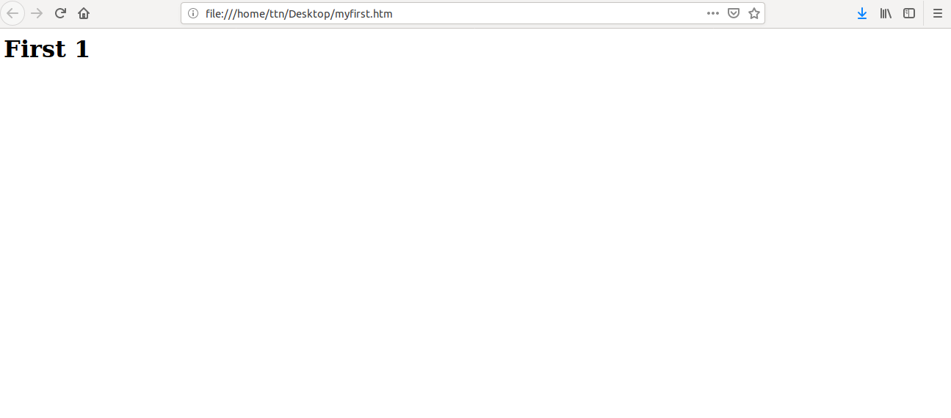

**2.Select a ID name "#test" and add class "load" when DOM is loaded**

**Ans-** <html>

<head>

<title>The jQuery Example</title>

<script type = "text/javascript"

src = "https://ajax.googleapis.com/ajax/libs/jquery/2.1.3/jquery.min.js">

</script>

<script type = "text/javascript">

$(document).ready(function() {

$(“#test”).addClass(“load”)

});

</script>

</head>

<body>

<h1 id="test">second 2</h1>

</body>

</html>

**3.Change the color of element which class name end with "-new"**

**Ans-**

<!DOCTYPE html>

<html>

<head>

<meta charset="utf-8">

<script src="https://ajax.googleapis.com/ajax/libs/jquery/3.1.1/jquery.min.js"></script>

<script>

$(document).ready(function(){

$("[class$=new]").css("color", "blue")

})

</script>

</head>

<body>

<div class="fid">

<h3 class="my-new">first is here</h3>

<h3 class="second">second </h3>

</div>

</body>

</html>



**4.Disable submit button using jquery attr method**

**Ans-**

<html>

<head>

<title>The jQuery Example</title>

<script type = "text/javascript"

src = "https://ajax.googleapis.com/ajax/libs/jquery/2.1.3/jquery.min.js">

</script>

<script type = "text/javascript">

$(document).ready(function() {

$("#myb").attr("disabled", true);

});

</script>

</head>

<body>

<h1 id="my-new">Third 3</h1>

<form>

First name:<br>

<input type="text" name="firstname" value="0">

<br>

Last name:<br>

<input type="text" name="lastname" value="0">

<br><br>

<input type="submit" value="Submit" id="myb">

</form>

</body>

</html>

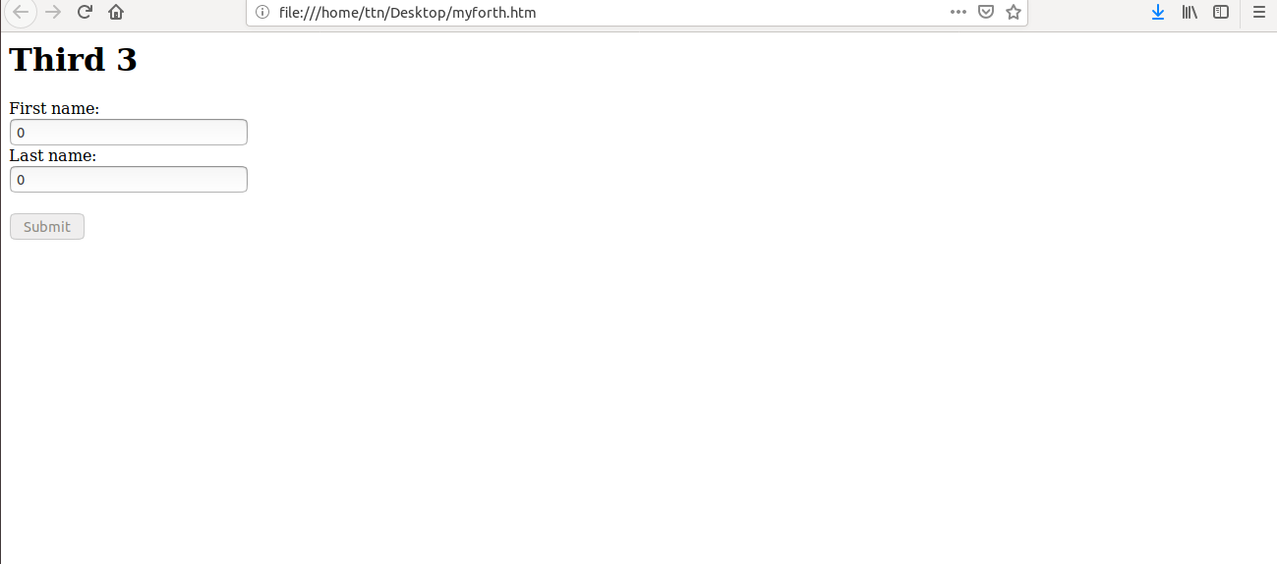

**5.Change the font size of ".target" which has parent element with id name "#main"**

**Ans-**

<!DOCTYPE html>

<html>

<head>

<meta charset="utf-8">

<script src="https://ajax.googleapis.com/ajax/libs/jquery/3.3.1/jquery.min.js"></script>

<script>

$(document).ready(function() {

$("#fid>.target").css("font-size", "80px");

});

</script>

</head>

<body>

<div id="fid">

<p class="target">This is a paragraph.</p>

<p class="forp">This is another paragraph.</p></div>

</body>

</html>

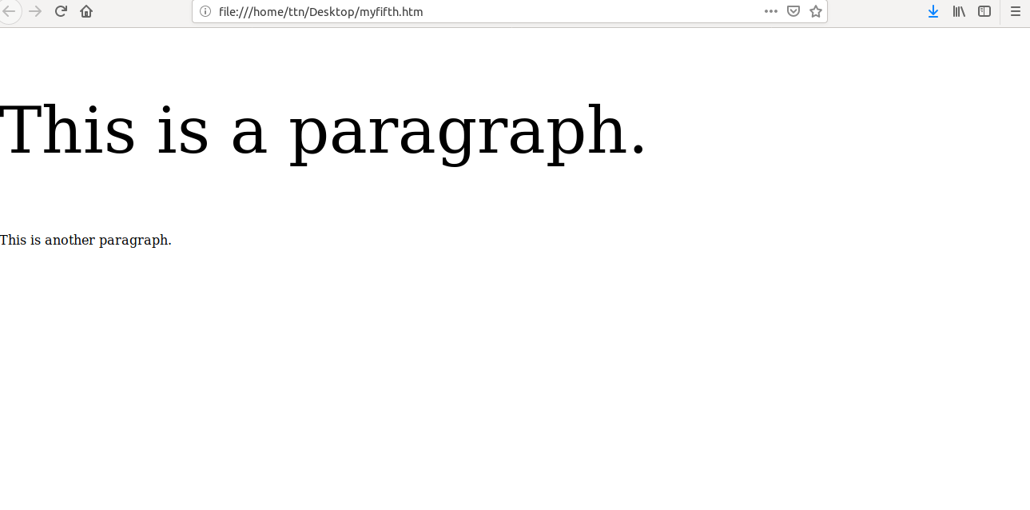

**6.After page load change the HTML of div element with "p" element**

**Ans-** <html>

<head>

<script src="https://code.jquery.com/jquery-1.9.1.min.js"></script>

<script>

$( window ).on( "load", function() {

$("div").replaceWith("<p>New para</p>");

});

</script>

</head>

<body>

<div>Here is the division</div>

<p>Here is the para of my answer</p>

</body>

</html>

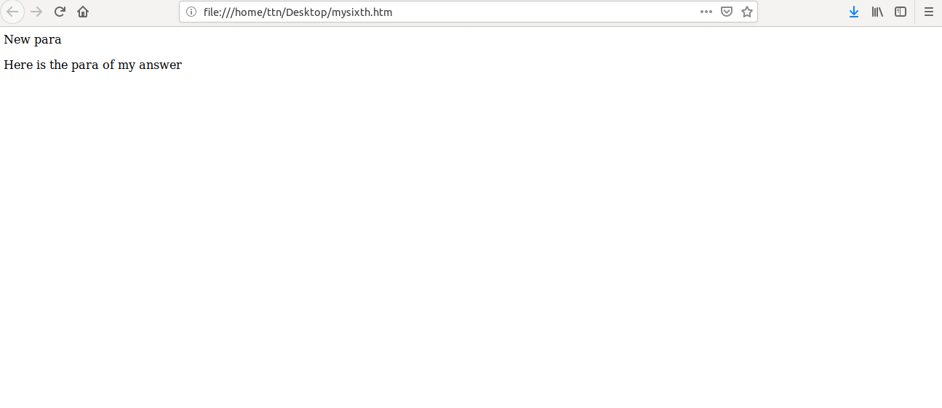

**7.Bind a click function to an "click" element and append next "click" next to it.**

**Ans-**

<!DOCTYPE html>

<html>

<head>

<meta charset="utf-8">

<script src="https://ajax.googleapis.com/ajax/libs/jquery/3.3.1/jquery.min.js"></script>

<script>

$(document).ready(function() {

$("#myb").click(function(){

$("#fid").append("<br><button id= 'newb'> new button</button><br>");

});

});

</script>

</head>

<body>

<div id="fid">

<p>7th question</p>

<p>This is another paragraph.</p>

<button id="myb">Try</button><br>

</div>

</body>

</html>

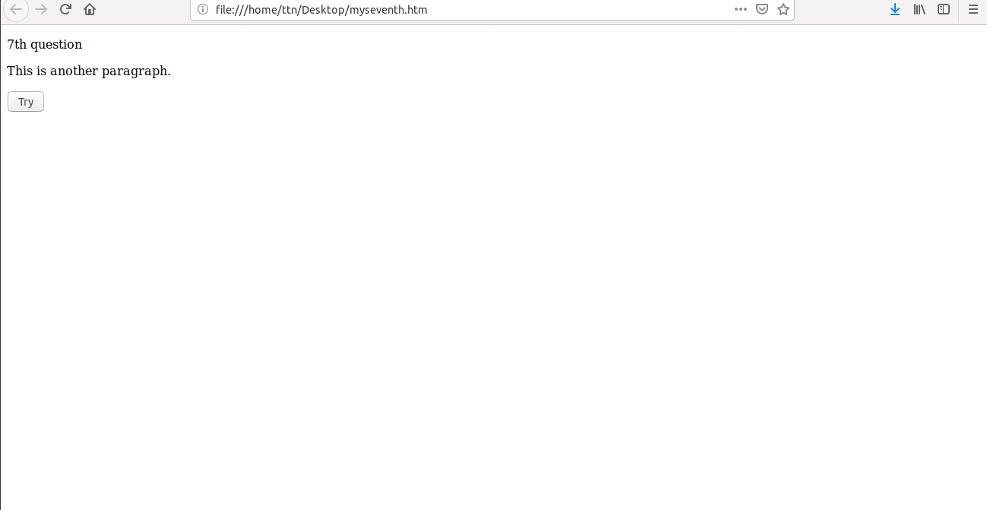

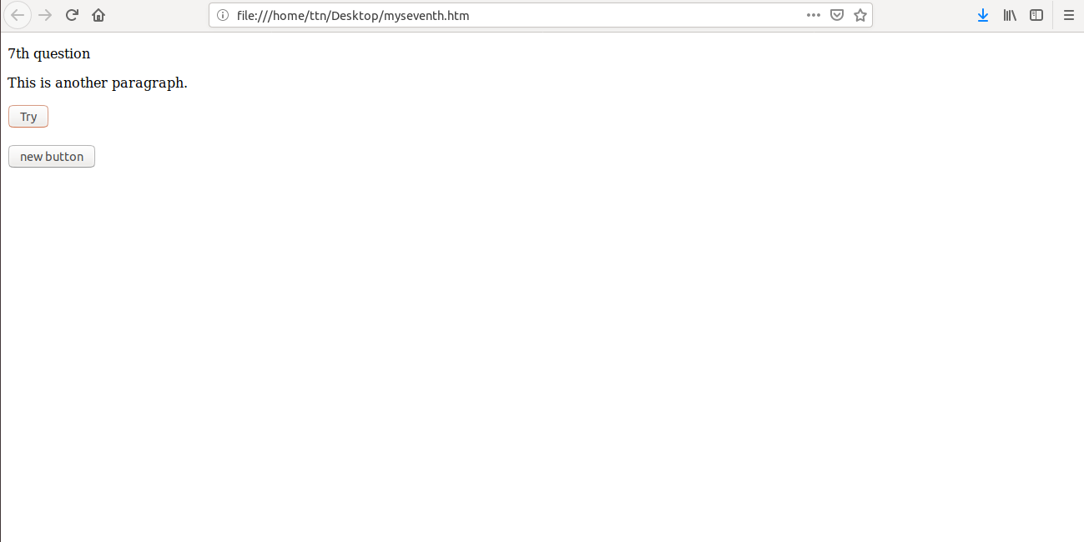

**8.Click event not working on element which added dynamicly or via script, make it work using .on method**

**Ans-**

<!DOCTYPE html>

<html>

<head>

<meta charset="utf-8">

<script src="https://ajax.googleapis.com/ajax/libs/jquery/3.3.1/jquery.min.js"></script>

<script>

$(document).ready(function() {

$("#myb").click(function(){

$("#fid").append("<br><button id= 'newb'> new button</button><br>");

});""

$(document).on("latest","latbtn",function(){

$("#fid").append("<br><button id= 'latestb'> latest button</button><br>");

});

});

</script>

</head>

<body>

<div id="fid">

<p>7th question</p>

<p>This is another paragraph.</p>

<button id="myb">Try</button><br>

</div>

</body>

</html>

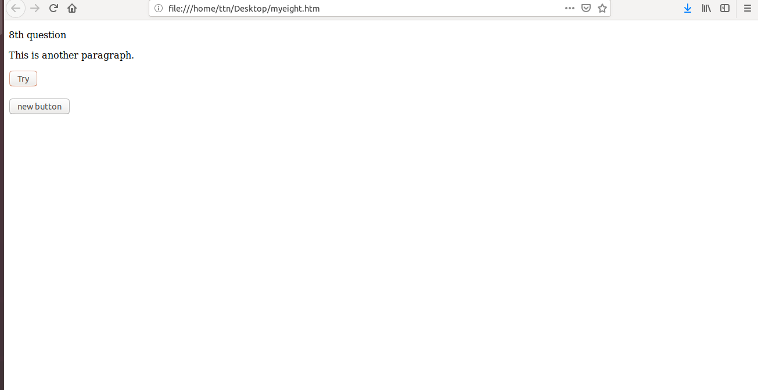

**9.Get dropdown selected value on onchanage event and append in div container**

**Ans-**

<!DOCTYPE html>

<html>

<head>

<meta charset="utf-8">

<script src="https://ajax.googleapis.com/ajax/libs/jquery/3.3.1/jquery.min.js"></script>

<script>

$(document).ready(function() {

$("#myse").change(function(){

$("#container").append("<h5>"+$("#myse").val()+"</h2>")

});

});

</script>

</head>

<body>

<div id="fid">Choose from the option

<select id="myse">

<option value="tiger">Tiger</option>

<option value="fox">fox</option>

<option value="cat">cat</option>

<option value="dog">dog</option>

</select>

</div>

<div id="container">

</div>

</body>

</html>

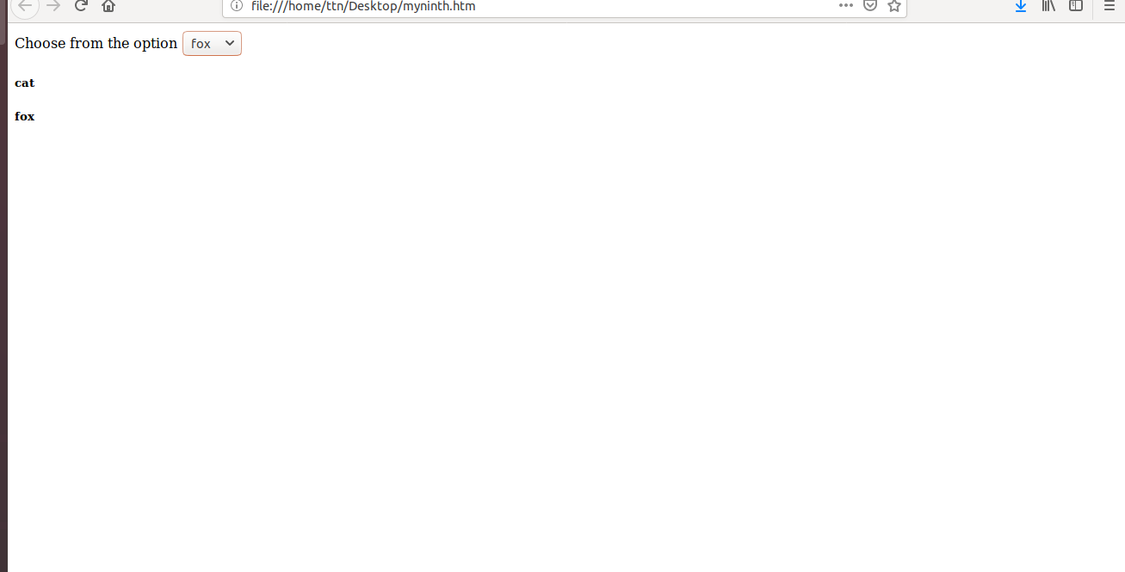

**10.Create a dropdown menu using hover method in jquery**

**Ans-**

<!DOCTYPE html>

<html>

<head>

<meta charset="utf-8">

<script src="https://ajax.googleapis.com/ajax/libs/jquery/3.3.1/jquery.min.js"></script>

<script>

$(document).ready(function() {

$("$myb").hover(function(){

$('#mydd').slideDown('fast');},

function(){

$('#mydd').slideUp('fast');});

});

});

});

</script>

</head>

<body>

<div id="fid">Choose from the option

<button id="myb">click to create dropdown</button>

<div id="mydd" style="display:none">

<button>tiger</button>

<button>lion</button>

<button>dog</button>

</div>

</div>

<div id="container">

</div>

</body>

</html>



**11.On clicking on "**[**google**](https://www.google.com/)**" tag. It is taking us to google home page. Stop it from happening.**

**Ans-**

<!DOCTYPE html>

<html>

<head>

<meta charset="utf-8">

<script src="https://ajax.googleapis.com/ajax/libs/jquery/3.3.1/jquery.min.js"></script>

<script>

$(document).ready(function() {

$("#togoogle").attr("href","");

});

</script>

</head>

<body>

<div id="fid">

<a id="togoogle" href="https://www.google.com/">Google</a>

</div>

</body>

</html>

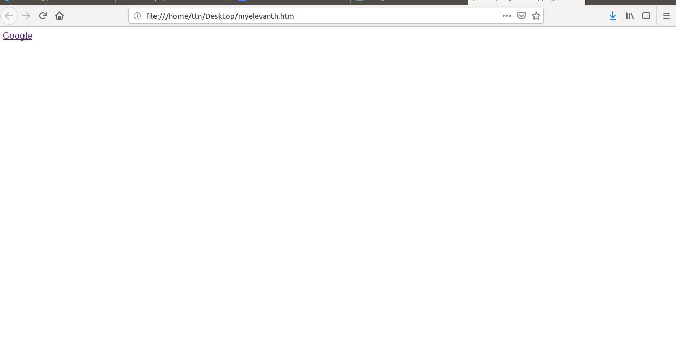

**12.We have bind a click funtion to parent div but we want stop it from performing when user clicks on its child li**

**Ans-**

<!DOCTYPE html>

<html>

<head>

<meta charset="utf-8">

<script src="https://ajax.googleapis.com/ajax/libs/jquery/3.3.1/jquery.min.js"></script>

<script>

$(document).ready(function() {

$("#childid").click(function(){

$("$fid").off("click");

$("$tid").append("<br><h3>child click</h3>");

});

});

</script>

</head>

<body>

<div id="fid" style="width:360px;height:260px;background-color:red">

<div id="childid" style="width:150px;height:150px;background-color:green"></div>

</div>

<div id="tid">here:

</div>

</body>

</html>

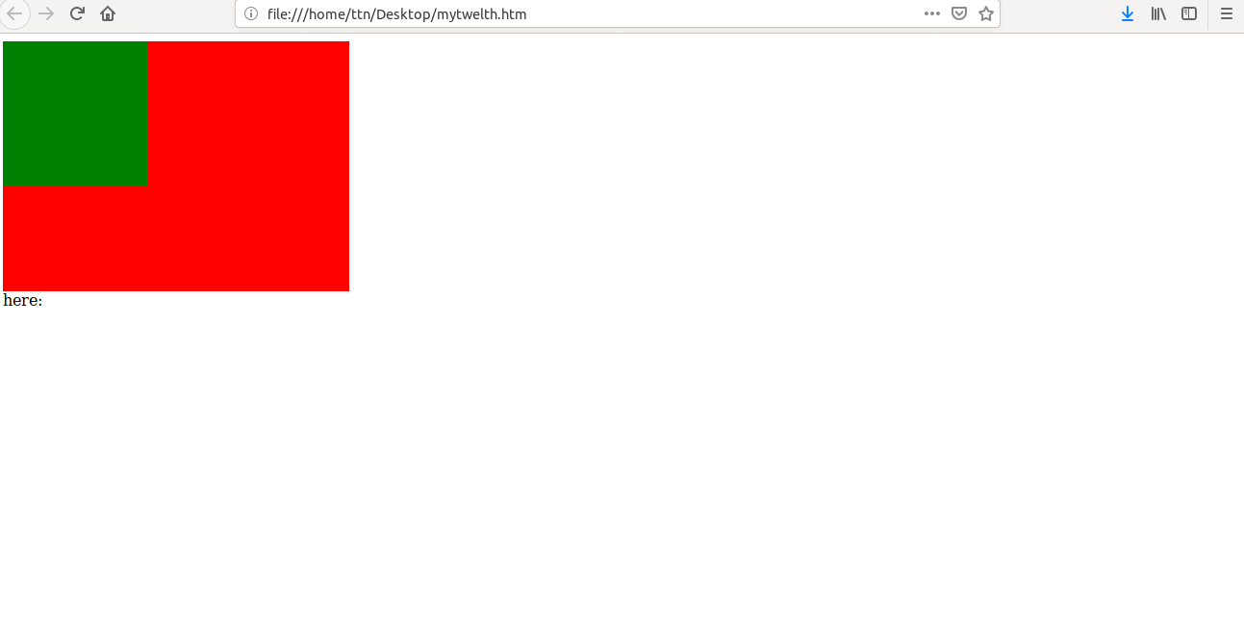

**13.Get the max height of elements using jquery each method**

**Ans-**

<!DOCTYPE html>

<html>

<head>

<meta charset="utf-8">

<script src="https://ajax.googleapis.com/ajax/libs/jquery/3.1.1/jquery.min.js"></script>

<script>

$(document).ready(function(){

var max = -1;

$(".main > div").each(function() {

var h = $(this).height();

max = h > max ? h : max;

});

$("#container").append("<h2> Maximum height of elements is" + max + "</h2>")

})

</script>

</head>

<body>

<div class="main">

<div id="myf1" style="background-color: red; width:50px;height:30px"></div><br>

<div id="myf2" style="background-color: blue; width:30px;height:20px"></div><br>

<div id="myf3" style="background-color: yellow; width:30px;height:50px"></div><br>

</div>

<div id="container">

</div>

</body>

</html>

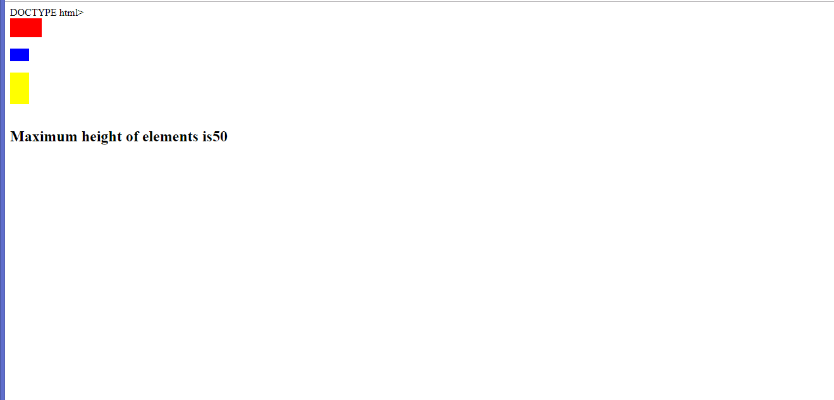

14.Change color of every cell which has numberl larger than 10.

Ans-

<!DOCTYPE html>

<html>

<head>

<meta charset="utf-8">

<script src="https://ajax.googleapis.com/ajax/libs/jquery/3.3.1/jquery.min.js"></script>

<script>

$(document).ready(function() {

$("td").each(function(){

if($(this).html()>10){

$(this).css({"background-color": "red"});

} });

});

</script>

</head>

<body>

<div id="fid">

<table id="myt" border="1px" style="width:100%">

<tr>

<td>12</td>

<td>23</td>

<td>4</td>

</tr>

<tr>

<td>4</td>

<td>11</td>

<td>43</td>

</tr>

<tr>

<td>1</td>

<td>3</td>

<td>9</td>

</tr>

</table>

</div>

</body>

</html>

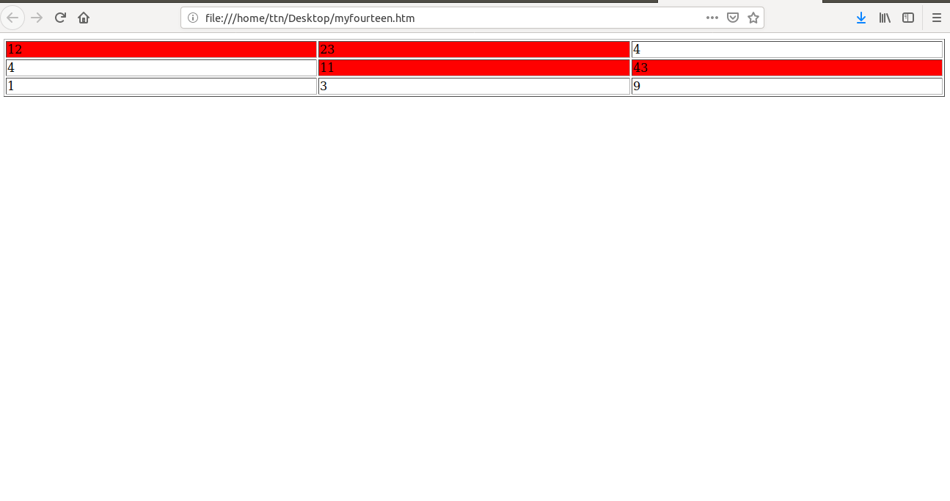

**15.Retrive the data from server using ajax get call**

**Ans-**

<!DOCTYPE html>

<html>

<head>

<meta charset="utf-8">

<script src="https://ajax.googleapis.com/ajax/libs/jquery/2.1.3/jquery.min.js"></script>

<script>

$(document).ready(function() {

$("#childid").click(function(){

$("$fid").off("click");

$("$tid").append("<br><h3>child click</h3>");

});

});

</script>

</head>

<body>

<div id="fid" style="width:360px;height:260px;background-color:red">

<div id="childid" style="width:150px;height:150px;background-color:green"></div>

</div>

<div id="tid">here:

</div>

</body>

</html>

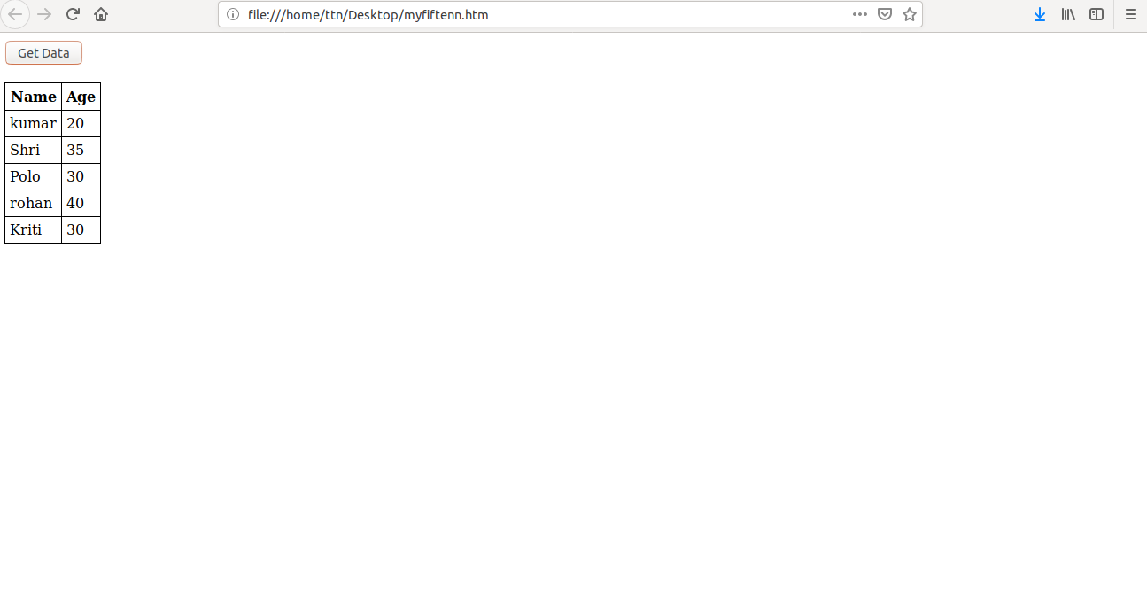

**16.Add cross button on row and bind click function which make a delete request to server, after success event remove the row from dom**

**Ans-**

<!DOCTYPE html>

<html>

<head>

<meta charset="utf-8">

<script src="https://ajax.googleapis.com/ajax/libs/jquery/2.3.1/jquery.min.js"></script>

<script>

var json;

$(document).ready(function(){

$("#get_data").click(function(){

$("#table_head").children().replaceWith("")

$("#table_body").children().replaceWith("")

$.ajax({url: "https://api.myjson.com/bins/mhh92", success: function(result){

$("#table_head").append("<th> Name </th> <th> Age </th>")

$("#data").attr({"border":"1", "cellpadding":"5px"})

putJsonInTable(result);

json = result;

}});

})

})

var putJsonInTable = function(data){

var i = 0

data.forEach(function (item) {

$("#table_body").append("<tr> <td>" + item.name + "</td> <td> <button class='b" + i +"' id='del_btn'>x</button> </tr>")

i++

});

}

$(document).on("click","#del_btn",function(){

var clicked_id = $(this).attr("class")

json.splice(clicked_id[1],1)

$("#table_body").children().replaceWith("")

putJsonInTable(json)

})

// my json file

//[{"name":"kumar","age":20},{"name":"Shri","age":35},{"name":"Polo","age":30},{"name":"rohan","age":40},{"name":"Kriti","age":30}]

</script>

</head>

<body>

<h2>Solution 16</h2>

<div id="main">

<button id="get_data">Get Data!</button><br><br>

<div id="container">

</div>

<div>

<table id="data" style="border-collapse: collapse;">

<thead id="table_head">

</thead>

<tbody id="table_body">

</tbody>

</table>

</div>

<div>

<table id="data1" style="border:1; border-collapse: collapse;">

<thead id="table_head1">

</thead>

<tbody id="table_body1">

</tbody>

</table>

</div>

</div>

</body>

</html>

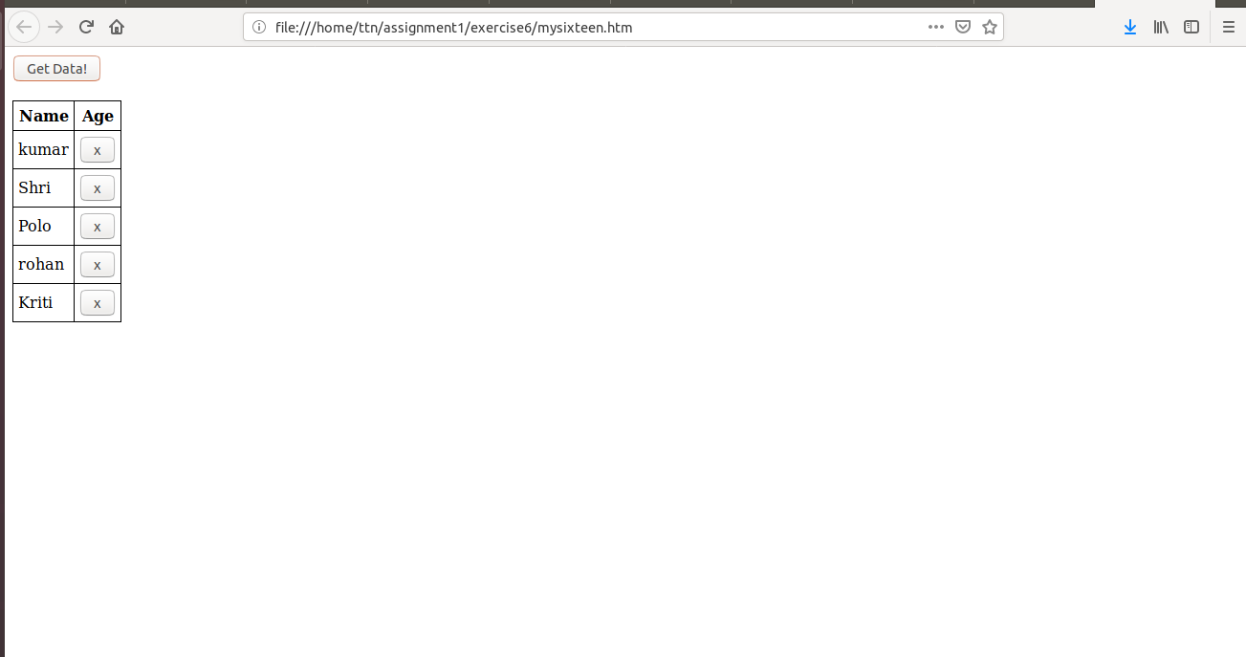

**17.Create a image array and in div create a slide show to animate images of delay of 500ms.**

**Ans-**

<!DOCTYPE html>

<html>

<head>

<meta charset="utf-8”>

<script src="https://ajax.googleapis.com/ajax/libs/jquery/2.3.1/jquery.min.js"></script>

<style>

#slider{

width:200px;

height:200px;

overflow:hidden;

}

#slider .slides{

display: block;

width: 200px;

height: 200px;

margin: 0;

padding: 0;

}

#slider .slide{

float:left;

list-style-type: none;

width:200px;

height:200px;

}

</style>

<script>

$(document).ready(function () {

$("img").css("display", "none");

$('#0').css("display", "block");

var len = $("img").length

console.log(len);

slideshow();

var count = 1;

function slideshow() {

if (count == len - 1) {

$("img").css("display", "none");

$('#' + count).css("display", "block");

count = 0;

} else {

$("img").css("display", "none");

$('#' + count).css("display", "block");

count++;

}

setTimeout(slideshow, 500)

}

})

</script>

</head>

<body>

<div id="slider">

<img id="0" src="exercise6/joshua-earle-63441-unsplash.jpg">

<img id="1" src="exercise6/joshua-earle-63441-unsplash.jpg">

<img id="2" src="exercise6/joshua-earle-63441-unsplash.jpg">

<img id="3" src="exercise6.joshua-earle-63441-unsplash.jpg">

</div>

</body>

</html>